Nepal college of information echnology
Assessment
Level: Bachelor | Semester – Fall | Year : 2015
Programme: BE IT/Software |  | Full Marks : 100
Course: Engineering Mathematics-I |  | Time : 3hrs.
Candidates are required to give their answers in their own words as far as practicable.
The figures in the margin indicate full marks.

Attempt all the questions.

1. (a) Define continuity and differentiability of the function check the continuity and differentiability of the faction.
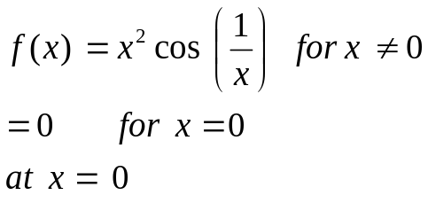 [8]
Or
State Leibnitz theorem. Use it to prove , if 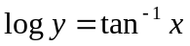.

(b) State Lagrange's Mean value theorem and give its geometrical meaning. Find a point on the parabola 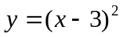, where the tangent is parallel to the secant joining the points (3,0) and (4,1) using MVT. [7]

2. (a) Evaluate: 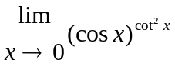 [7]
(b) Show that the semi vertical angle of a cone of maximum volume and given slant height is 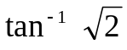. [8]
Or
Define asymptotes of the curve and discuss its types. Find the asymptotes of 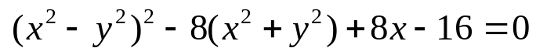
3. Integrate (any three) [3x5]
(a) 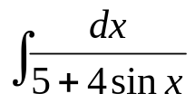
(b) 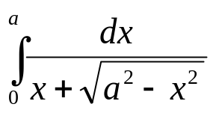
(c) 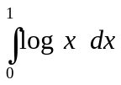
(d) Show that 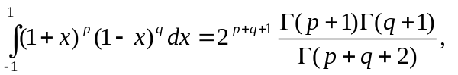for p>1 , q>1.
(e) 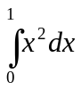 from the definition.
4. a) Find the area bounded by the parabola 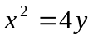 and the curve 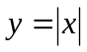. 7
OR
Find the volume of solid generated by revolving the asteroid 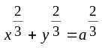 about x-axis.
b) Evaluate 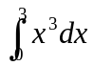 by using Trapezoid Rule, Simpson's Rule, with n=4 and compare the result with exact values. 8
5. a) Find the equation of the plane through (1,1,-1), (2,0,2) (0,-2,1) by vector method. 7
b) Define reciprocal system of vectors. If 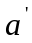,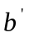, 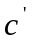is a reciprocal system of the vectors 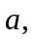, then ,is also the reciprocal of system ,, . 8
6. a) Define eccentricity of a conic section. Derive standard equation of hyperbola in its standard form. 8
b) Find the equation of an ellipse with focus at (-1,1), directrix x-y+3=0 and 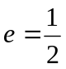. 7
7. Answer the following: 2*5=10
a) Find domain and range of the function 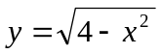.
b) Find the radius of curvature of the curve 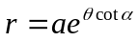
c) Find the condition for the line y=mx+c to be tangent to the parabola 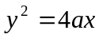.
d) Transform the equation x²+2cxy+y²=a² by turning the rectangular axes through angle
e) Find the entire length of a circle of radius r with centre (0,0).

